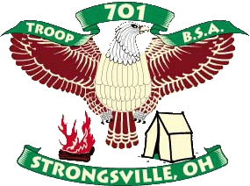
Boy Scout Troop 701
In partnership with
Easter Seals Northern Ohio
Is sponsoring a
Fill the Truck Drive

On Saturday, May 14th
Staples Plaza
(12421 Pearl Rd, Strongsville OH)
9:00 am – 5:00 pm
Boy Scout Troop 701 is partnering with Easter Seals to help raise funds for children and adults with disabilities in Northern Ohio, and to offset the cost of equipment trailer maintenance and repairs, in addition to bus transportation to summer camp for Troop 701.

Anything made of cloth will be accepted. Donations can include but are not limited to: clothing, comforters, blankets, towels, sheets, shoes, stuffed animals, and purses. Donations will be reused, resold or recycled. Even stained, ripped and torn cloth items can be recycled so please consider donating these items as well.

Easter Seals is also accepting Books/CDs/DVDs/VHS tapes, kitchenware (dishes, silverware, pots/pans, etc.), small picture frames/wall hangings, small kids’ toys/games, knickknacks, and Jewelry. Non-Cloth ITEMS* MUST BE IN GOOD, CLEAN, TEAR FREE & WORKING CONDITION.

Please bag/box cloth items SEPARATELY from Non-cloth household items! All donations are tax deductible with receipts provided by Easter Seals!

If you have any questions or have a donation that you need us to pick up on or before Saturday, May 14th, please email troop701clothingdrive@yahoo.com or call 440-238-9158 to make arrangements.

Fill the Truck drives are a big “WIN” for everyone!
- Easter Seals’ Community Action Program supports vital services for children and adults with disabilities in Northern Ohio. The proceeds from the bulk sale of the contributions support programs such as speech therapy, home care, medical equipment loans, and summer camp opportunities.
- Strongsville Boy Scout Troop 701 was established in 1979 and has produced 125 Eagle Scouts in 36 year.

Your organization will raise much neeand adults with disabilities.

